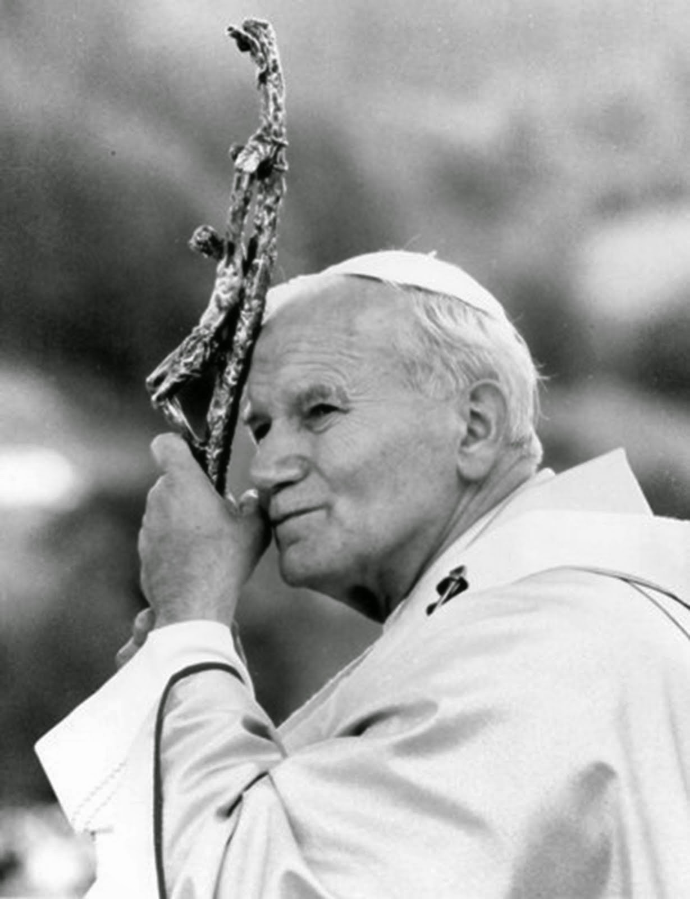  Totus Tuus  Summer missions  Parish Coordinator Booklet | Eucharist  ────  Marian Devotion  ────  Catechesis  ────  Vocations  ────  Fun  Diocese of  dodge city  910 Central Ave  Dodge City, KS 67801  620-227-1500  dcyouth.org  Summer 2020
First of all…
Thank you for inviting Totus Tuus to your parish! We are grateful for your willingness to join us in our efforts to lead young people to Christ. As the parish contact person you should have already set the specific week to have the Totus Tuus team in your parish. Now, to make sure everything runs smoothly, it’s time to take care of some details.

Coordinator Checklist
__ Register parish through provided form online
__ Submit forms of payment for Diocese ($1350 per team)
__ Receive confirmation from Diocese for Totus Tuus dates
__ Meet with Parish priest(s) and Director of Youth & Religious Education to discuss logistics & advertising
__ Enact advertising plan
__ Arrange accommodations for sleeping (pg.3)
__ 1 Host family for women
__ 1 Host family for men
__ Arrange meals (lunch & dinner to be provided by different family each day) (pg.3)
__ Saturday dinner
___ Sunday lunch & dinner
___ Monday lunch & dinner
___ Tuesday lunch & dinner
___ Wednesday lunch (& dinner if no potluck)
___ Thursday lunch (social dinner is preferred with middle school/high school that evening)
___ Friday lunch
__ Arrange & schedule parish pot luck (if applicable) (pg.3)
__ Compile list of addresses team will be going to (host families, dinners, etc)
__ Coordinate volunteers to assist the grade school program (if needed)
__ Send out registration forms to families
__ Confirm mass/confession/adoration times with priest(s)
Week of Totus Tuus:

__ Been contacted by team leader
__ Meeting with team & priest(s) on Saturday to discuss logistics

__ Locate/obtain water supplies for Friday afternoon water fight
__ Hose
__ Large wading pools/Stock tank/Garbage cans
__ Any snacks to provide kids if desired (popsicles, ice cream, etc.)
__Water to drink after games

The team leader will call you a week in advance to go over the details of Totus Tuus to make sure that the parish and the team are on the same page. Each team has been provided contact information that was given when you registered your parish. If this information changes, please let Emma Showalter know so that this can be given to the teams beforehand.

Emma Showalter
dcyouth@dcdiocese.org
620-227-1540

Team Leader for your parish
Name:
Phone #:

Co-Leader for your parish
Name:
Phone #:

Housing
Host families are asked to provide sleeping arrangements, a simple breakfast, and possibly snacks to refuel. Men and women are to be housed separately, therefore only two houses are needed. A teacher should not stay at a host family home by themselves.

Meals
Please plan to provide all of the team’s meals while they are in your parish. So not to over burden the host family, typically lunch and dinner are provided by the parish and/or other families. The teachers eat lunch with the children so meals need to be prepared ahead of time. Please arrange for families in the parish to invite the team to dinner. A family may prepare and serve the meal, have the food brought in, or take the team out to eat, whichever the family prefers.
Arrange for lunches to be brought into the parish by 12:00pm if possible, Monday – Friday.
Arrange for dinners to be provided by families at 5:30pm, Sunday – Tuesday, Thursday and Friday.
For the parish potluck please be sure to invite the parish several weeks in advance. The team will send home fliers that Wednesday with the children to remind the parents.

Parish Potluck Supper (optional)
The parish is asked to sponsor a potluck supper for the children, their families and parishioners on Wednesday evening. The potluck supper should begin at 5:30 p.m. and wrap up around 7:00 p.m. so as to allow time to prepare for the high school class. Once again, this activity and the time are suggested; the day and time can be adapted to meet the needs of each individual parish.
We encourage this to be a parish-wide event. This gathering gives the team the opportunity to meet with families and other parish members. This is an excellent opportunity to meet parents and for them to get to know the teachers, where they are from, etc. During the evening the Team Leader will introduce the team and explain a little about the history and mission of Totus Tuus. To close the night, the team will lead the children in some songs for the parish.

Facilities
In order for the grade school program to run smoothly, the team needs one large hall or room for main assemblies (this room may be used as a lunchroom or classroom, if necessary). The amount of participants and the number of teachers assigned to each parish will determine additional rooms.
_____ Reserve Facilities
_____ Readying of teaching facilities for the summer program
_____ Chalk/Dry Erase markers and erasers
_____ Chalk Boards/Dry erase boards
_____ Bibles (if available)
_____ Bathrooms - marked “boys”, “girls” and “adults” (if possible)
_____ Lunchroom - place for volunteers to prepare lunches and drinks
_____ Gathering area for songs and announcements
_____ Playground area and possible equipment
_____ Trash cans
_____ Choice of classrooms (team members will set up)
_____ Large Crucifix (for meditation with jr. high/high school youth)

Volunteers
We ask that a few volunteers be present throughout much of the day, the number will depend upon the number of participants and the particular needs of your parish. The main times that they are needed are during Mass at 11:30 am, and between 12:15 p.m. and 1:55 p.m. for lunch and breaks. We have also found that help is needed in the first and second grade classrooms as well. Often we invite the participants in the high school program to help during the day and it’s a way for the high school students to get to know the team better.

Team Schedule
6:40am: Rise & Shine
7:30am: Arrive at Church, Morning Prayer, Rosary, Set up Classrooms
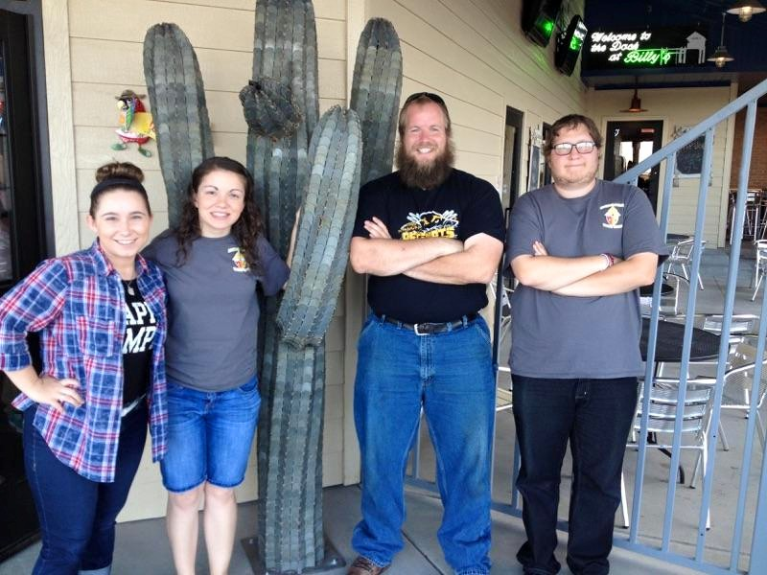
9:00am: Welcome/Pump-Up
9:20am: Class #1
10:00am: Snack
10:15am: Class #2
10:45am: Music Prep and Exam. Of Cons.
11:00am: Mass Prep & Bathroom break – Confession for each class
11:30am: Mass
12:15pm: Lunch & Recess
1:00pm: Water break/Cool down/Skit
1:15pm: Class #3
1:50pm: Snack(Optional) /Restroom/TT Theater (if no snack)
2:10pm: Class #4 (Children’s adoration on Thursday)
2:40pm: Closing/Banana Song/Prayer
3:o0pm: Send kids home

3:15pm: Evening Prayer, Chaplet of Divine Mercy, Free time
5:30pm: Dinner
6:30pm: Arrive at church, set up evening program
7:00pm: Evening program with middle school & high school
8:00pm: Adoration begins (on adoration/confession night)
9:00pm: Night prayer & Goodbyes

Mass and Confession
It is in the Sacraments, especially in the Eucharist, that Christ Jesus works most fully for the redemption and sanctification of all mankind. We realize that Totus Tuus asks a lot of our priests who are already very busy, and for their presence and participation in the program we are extremely grateful. We have found over the years that celebrating and participating in the sacraments on such an intimate level has a tremendous effect on the children. We strive to help the children participate fully and actively in the liturgy and consider this an integral part of our program.
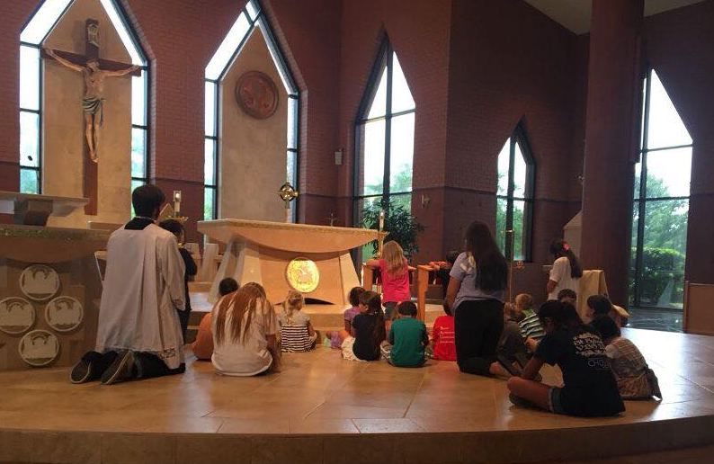
It is the responsibility of the parish coordinator to arrange the liturgical and sacramental events with the priest.
Since the Eucharist is the source and the summit of the Christian life, Totus Tuus encourages the daily celebration of Holy Mass at 11:30 a.m. We also suggest that opportunities for the Sacrament of Reconciliation be made available every day before Mass, beginning at 11:00 a.m. This schedule can be adapted to meet the needs and special circumstances of your parish. If you would like to discuss alternate schedules, please contact the Office of Faith Formation as soon as possible.
The oldest students will be sent to Confession on Monday and younger grades as the week progresses. If your parish has many young people involved in the program, the pastor may find it helpful to invite a fellow priest to assist.
The youth will participate at Mass by serving, bringing up the offertory gifts and proclaiming the readings and petitions. Totus Tuus team members will lead the children in a few songs during Mass; therefore, it is not necessary to ask the music director or choristers to be there.
The team will prepare the children for Mass and Confession, and they will practice the songs as well. The children will be expected to behave during Mass—and at all times during the week. Their Friday afternoon schedule depends on it!
If a priest is unable to preside at and/or secure a replacement for the Mass at any point during the week, the team will take the children to the church to pray the Rosary, Mid-day Prayer, or the Stations of the Cross.
Children’s Adoration will take place on Thursday afternoon. If your parish has a perpetual Adoration chapel, the children will be taken there; if not, the children will be taken to the Church during this time. This will be led by the team and involvement from the pastor is completely optional. It is suggested to give notice to the scheduled Adorers that the children will be in the Adoration chapel.

Friday Afternoon
On Fridays, we follow the usual schedule through lunch, but then it is modified to allow for “fun time” in the afternoon. Students still bring their lunches or some parishes like to take this opportunity to have a “cook out” (usually hot dogs and chips). After lunch there will be no formal classes.
At 1:10 p.m. on Friday afternoon, their are several options for activities that the students can participate in. In the past, a human sundae (where the teacher becomes ice cream and the students bring a topping to pour on the teacher whom they’ve voted upon) has been done prior to the water game.
The water games are scheduled to begin at 1:45pm. Friday afternoon’s festivities can be held in a nearby park or recreation area, or just in a large, open area (the parking lot will suffice) on your church grounds. During these water games will be a water-balloon toss and a “water fight” for which students can bring water guns, squirt bottles, buckets, etc. The team will provide the water balloons. By about 2:40 p.m. the water fight ends and students help the team clean up the area.
The parish is asked to provide water hoses and wading pools or a stock tank, etc. Parishes may also choose to provide popsicles, ice cream, or other treats at the conclusion of Friday afternoon.
Some parishes ask the local fire department to send a truck and join in the water fight. This adds a considerable amount of water (and fun), but is completely optional.
Parents should be warned that children will be wet and possibly dirty when they are picked up. Please recommend that the students come wearing something that can be ruined; they will not be allowed to change clothes. The team will talk to the children about Friday afternoon at the close of the day on Thursday, giving them the rules of the day, what to bring for the water games, and what to wear.
The day is closed, as is every day, with song and prayer.

